74.06.16a
From George Bennett
RB MSS M132, Library, Royal Botanic Gardens Melbourne.

Sydney June 16 1874
My Dear Baron Von Mueller,
Carron informs me that there is no doubt of Ficus columnaris and rubiginosa being quite distinct; in the Flora Australiensis the two have been confused together; they are not only distinct but F. rubiginosa is quite a different plant in appearance & is found much further south. Carron says that perhaps the specimens sent to Mr Bentham were not in fruit & the leaves below the average size for he says the foliage of this tree very much resembles those of F. macrophylla being often six to nine inches long and three to four inches broad with stipules three to four inches long, the fruit receptacles roundish or somewhat pear shaped and three quarters of an inch in diameter; while the leaves of F. rubiginosa are always much smaller, more ferrigunous beneath and the stipules are of a dull rusty colour and not more than half the length. The fruit receptacles are also very much smaller being scarcely half an inch in diameter and of a different appearance, in fact, Carron says, the whole plant whether young or old has a very different aspect from that of F. rubiginosa and certainly bears a closer resemblance to Ficus macrophylla than any other Fig. With our united kind regards I remain
My Dear Baron
Yours sincerely
George Bennett

P.S. I received a letter from Mr Moore from Aden & he was very well to April 25th
I have had the sketch of F. rubiginosa photographed & enclose you a copy.

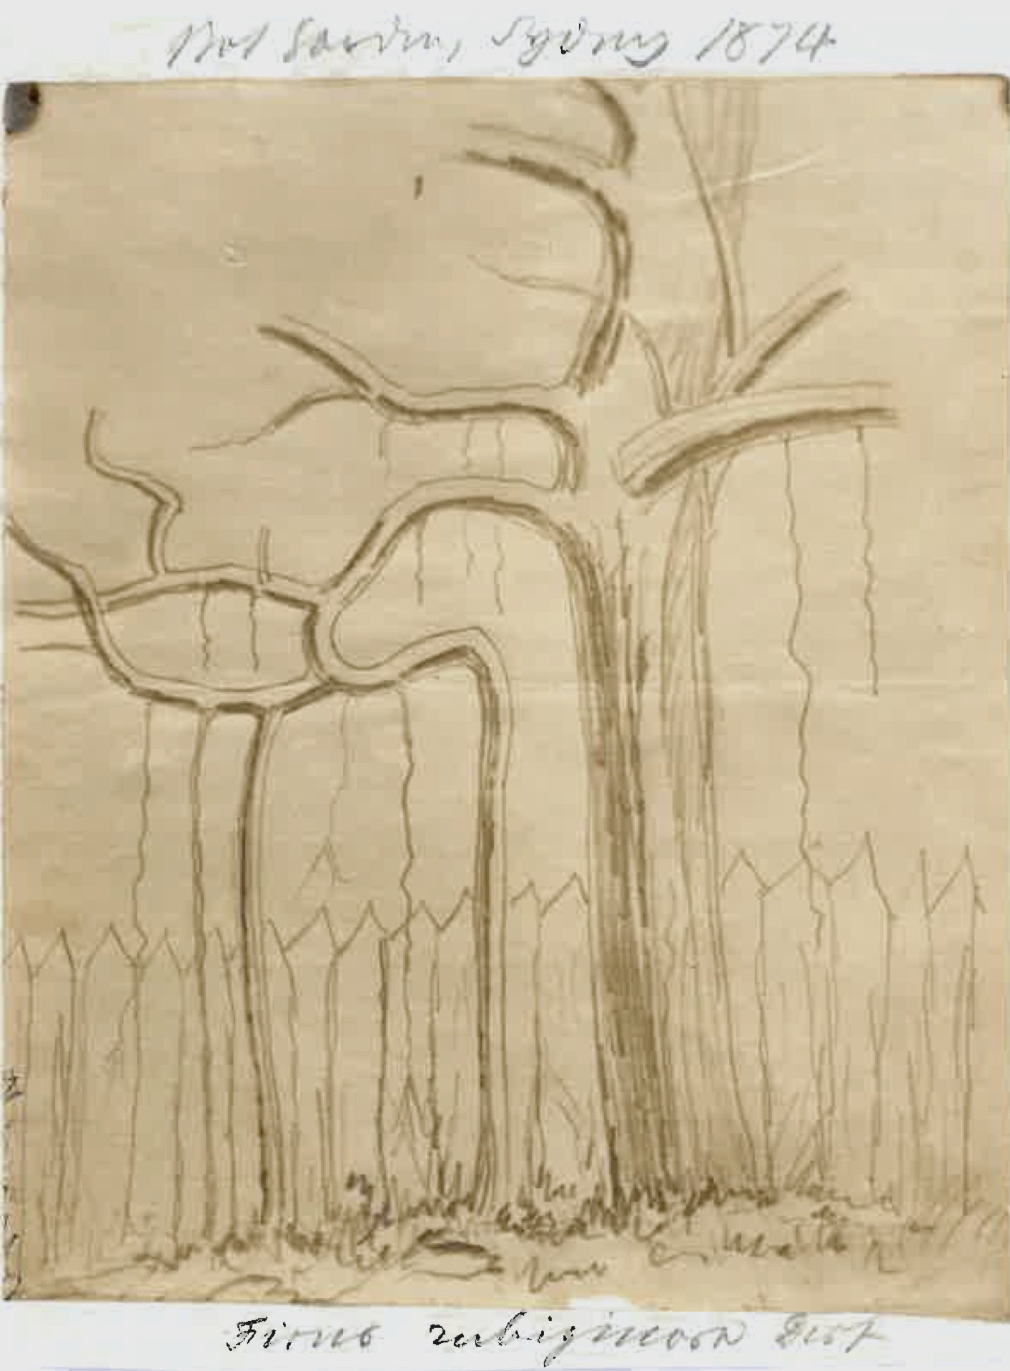

Ficus columnaris
Ficus macrophylla
Ficus rubiginosa

MS found with a specimen of Ficus macrophylla (MEL 239987). The correspondent is George Bennett, d. 1893.
Bennett (1877) quotes extensively from the letter from Carron.
MS accompanied by a photograph of a sketch annotated above the image: 'Bot Garden, Sydney 1874' and below the image 'Ficus rubiginosa Desf’: 74-06-16a_image01.jpg

